**Pricing and Revenue Management Project Report**

**Jiahui Wang, Tingyu Xie, Weihao Zeng, and Jingbo Zhang**

Original Case: Revenue Management for Rose Hotel (Chapter 4)

<https://broncoscholar.library.cpp.edu/bitstream/handle/10211.3/194667/LeThu_Project2017.pdf?sequence=3>

**1. Introduction**

The Rose Hotel is a family owned full-service hotel in Pasadena, California. The hotel, which has 300 rooms, was originally built in 2000, acquired in 2005, and improved in 2015 with a huge investment. Although the annual demand for hotels in Pasadena is significant and Rose Hotel was just improved with a large investment, it still produces low annual revenue that does not meet the expectations of owners. The hotel has generated declined occupancy rates for more than two years. Other reasons for the hotel’s low revenue include its ineffective promotion strategies and the strong industrial competition. Thus, the goal of this project is to conduct a pricing and revenue management consultant for Rose Hotel.

To help Rose Hotel increase its annual revenue with better pricing strategies, three aspects are considered. Firstly, the differential pricing strategy is applied for the 300 rooms in Rose Hotel for different customer segments and different booking periods. Secondly, different protection levels are set for different booking periods. Thirdly, the optimal overbooking level is calculated based on the differential prices. Then we come up with questions (please see the next part) related to these three aspects. To create models for the questions, we focus on two customer segments, *leisure travelers* and *group travelers* (major customer segments of Rose Hotel), and three booking periods, including *booking 0-13 days in advance (Period 1), booking 14-28 days in advance (Period 2),* and *booking more than 28 days in advance (Period 3)* (general booking phases used in the hotel industry). Additionally, we used the three-tier price structure, which divides rooms into rooms with full price sold in Period 1, rooms with 5% discount price sold in Period 2, and rooms with 10% discount price sold in Period 3. The strategy of setting protection levels for the three-tier prices in different booking periods is shown below.

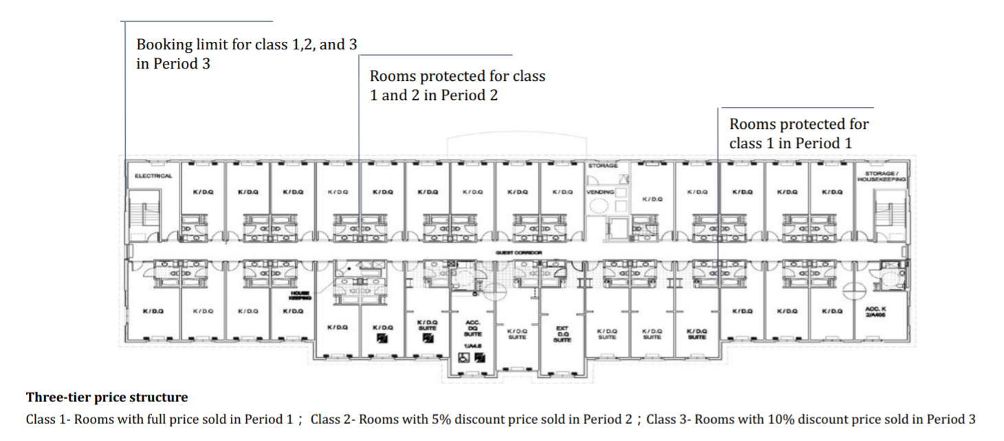

**2. Questions**

Since the original case study has already shown the answers to the questions proposed in that case, we would like to come up with our own questions to help Rose Hotel in revenue management based on the motivation that we mentioned in the introduction part.

**Question 1**

Currently, the room price of Rose hotel is $155 and the expected demand is 163. To increase the occupancy rate, Rose hotel is going to apply differential pricing strategy for leisure travelers in 3 booking periods, charging full price, 5% off and 10% off for 0~13 days ahead, 14~27 days ahead, and 28 days ahead respectively. Assuming that the full price is identical every day, the elasticity is 1.2 and the demand curve is linear, what would be the three differential prices for leisure travelers in order to maximize the revenue?

**Question 2**

Based on Question 1, what would be the protection levels for leisure travelers in different booking periods?

**Question 3**

If Rose Hotel wants to attract group travelers by offering an in-advance-booking discount, how can we make this strategy profitable and what will be the protection level for leisure travelers?

**Question 4**

Assuming that the reservations of leisure travelers are refundable while the reservations of group travelers are not refundable, suppose the accommodation fee is $300. what would be the overbooking limit for leisure travelers?

**3. Data Processing**

As is provided by the original case study, we have Rose Hotel’s booking data on two individual days (Apr 17, 2017 and Apr 24, 2017), which provides the leisure booking count for following several days; Specifically, for example, the table shows that on Apr 17, how many rooms were already booked for Apr 24, Apr, 25,..., and Jun 2, respectively. Below is part of the data table. And in this part we just focus on the leisure booking.

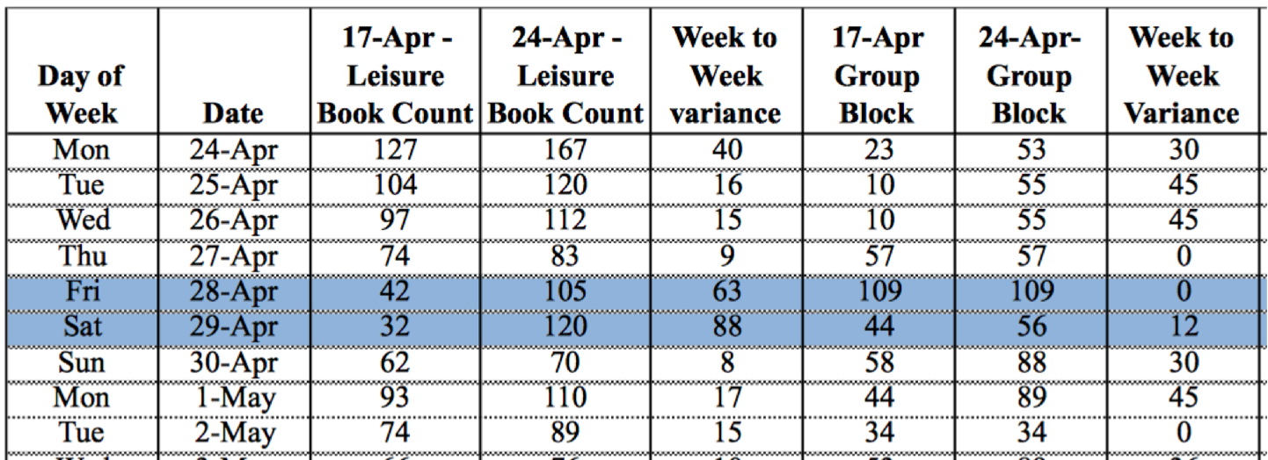

With the data provided, it is convenient to derive that for a certain day, how many rooms reserved for that day were booked each day before. For example, as shown in the fourth row of record, for Apr 27, 74 rooms were already booked 11 days before (booked on or before Apr 17 8:00 am, so we assumed it is total demand of 27-17+1 day before); meanwhile, by Apr 24, i.e., four days before Apr 27, 83 rooms were booked. Therefore, we can get two of the (X, Y) combinations: (11, 74) and (4, 83), where X is for the number of days in advance and Y is for accumulated demand before. We worked similarly for every record in the table, and got lots of (X, Y) combinations and then plotted them all in X-Y axis. We found that there were significant relationships between X and Y according to the pattern and run a regression model on the data, which looks pretty good to provide a fit on our data as shown below:

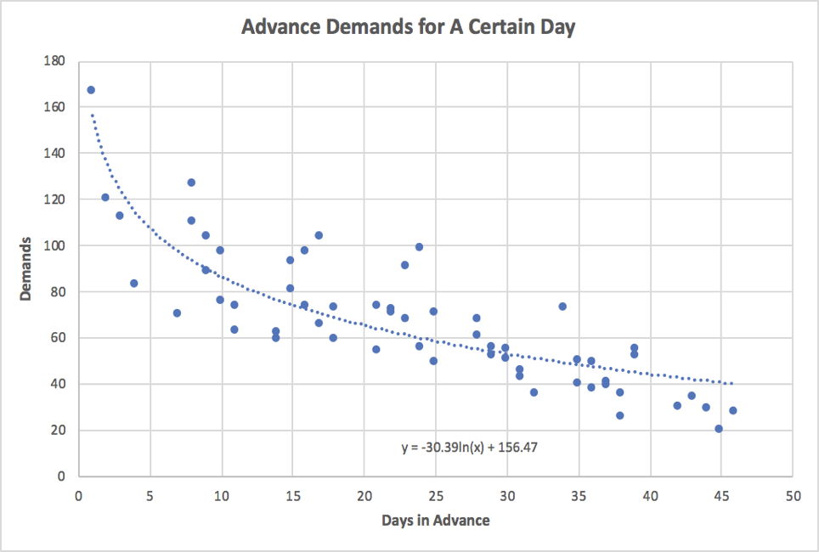

So far, we can get estimated accumulated advance demands for a certain day with the regression model supposing that the demand for room keeps constant whatever the “certain day” is. For instance, from our model, around 60 of today’s rooms were booked 25 days before. From the curve itself, we clearly see that there is negative relationship between X and Y, which fairly make senses considering that in reality, the total (or accumulated) demand for certain day’s rooms will get larger and larger when it is approaching that day.

With this model, we can get the estimated accumulated demand for each day in advance, and the corresponding “accumulated percentage”, i.e. what percentage of total demands for rooms for a day are booked in each day before that day. Examples are shown as follows:

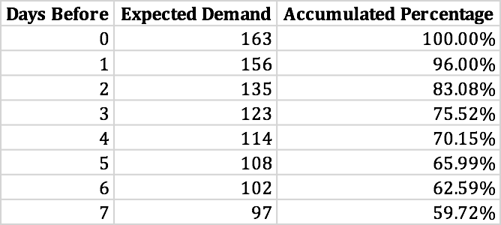

here, for instance, the accumulated percentage for 1 days before equals to 156/163. And for “0 days before”, which means it already reached the “certain day”, the model cannot provide a value for demand since x cannot be zero in ln(x). Alternatively, we regarded the demand for the same day’s rooms as last-minute demand, and approximately 4% of total demand, then the total demand would be 156/(1-4%) = 163.

With the accumulated percentage and days before information, then we can further get the proportion of the total demand for a certain day’s room from three different booking periods, four weeks (28 days) before, two to four weeks (14 - 28 days) before, within two weeks (0-13 days) before as mentioned in introduction:

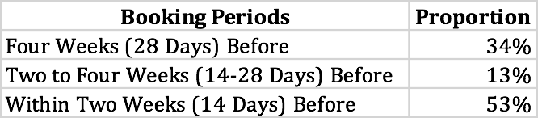

with this important table, we then further directly dealt with the proposed questions.

**4. Solution to Question 1**

To address the this question, we need make following assumptions:

* The demand curve is linear.
* The elasticity when price is $155 and demand is 163 would be 1.2. Since the Rose Hotel falls in the pricier end compared with its competitors, while the hotel’s occupancy rate is below the market average, the customer would be quite sensitive to the price changes.
* The percent of booking behavior would not change according to the price or the demand.
* The full price of each room is identical every day.

In order to run optimization for the revenue, we have to know the price and how the demand would change according to the price. Therefore, we are going to get the demand function first. From the question, we have:

elasticity (Ɛ) = 1.2, d(p=155) = 163

Then, from the definition of the elasticity, we can get the slope of the linear demand curve, and we then we get the demand function:

⇛d′(p) = -d(p=155)*Ɛ/155 = -1.26

⇛d(p) = 163-1.26*(p-155)

From the previous data processing part, we know there is 53.21% booking behaviors happen within 2 weeks before, 12.92% booking behaviors happen between 2 and 4 weeks before, and 33.87% booking behaviors happen at least 4 weeks before. Since we made an assumption earlier that the percent of booking behavior would not change according to the price or the demand, then the number of booking within 2 weeks would be d(P)*53.21%, the number of booking between 2 and 4 weeks ahead would be d(0.95p) * 12.92%, the number of booking at least 4 weeks ahead would be d(0.9P) * 33.87%.

Let’s denote S as the number of room sold in a period, then we can get the formula of revenue as:

Revenue= P*S0~2 + 0.95P * S2~4 + 0.9 P * S4~

= P*d(P)*53.21% + 0.95P *d(0.95p) * 12.92% + 0.9P * d(0.9P) * 33.87%

The above formula is a function about price. To maximize the revenue, we utilized Solver in Excel and find that we should set $148 as the full price. Compared to the original price $155, the revenue will increase from $25,265 to $25,418. Please see detailed calculations in the attached spreadsheet.

**5. Solution to Question 2**

After setting the best price for each time period, the next step is to take demand uncertainty into consideration. To maximum the revenue, it’s better to set a protection level for customers who are willing to pay high price. Therefore, the question is what is the best protection level for high-class demand in each time period. Figure below shows the booking and protecting process in each period. Obviously, the question need to be solved by two steps. First, find the protection level for class 1 and 2 in period 3. Second, find the protection level for class 1 in period 2.

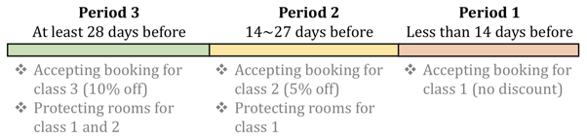

Here we assume that the demand is under normal distribution. The standard deviation of total demand is 40 and it will not change with price. Therefore, according to basic statistics knowledge, demand in each period will also conform to a normal distribution. The mean and standard deviation can be calculated by simply multiplying the value (mean or standard deviation) by the corresponding booking probability of each time period. The parameters of demand distribution in each period is shown in table below.

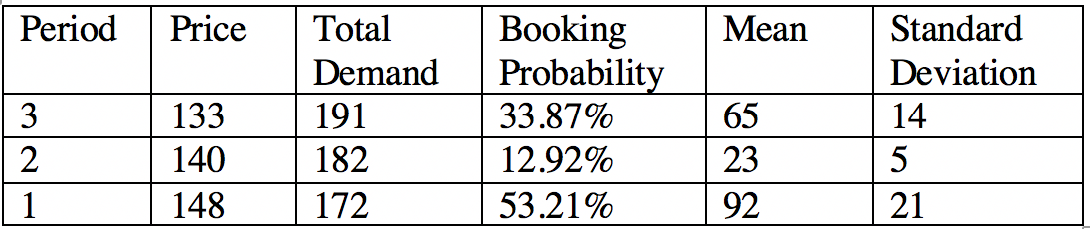

**Protection level calculation for period 3**

In period 3, we need to protect rooms for both class 1 and 2. We use two methods to solve this problem.

- **Method a**

Here, we treat class 1 and class 2 as two individual classes and calculate the protection level for each class separately. We use to represent the protection level in period j against class i. According to Littlewood’s formula, the protection level for each time period is

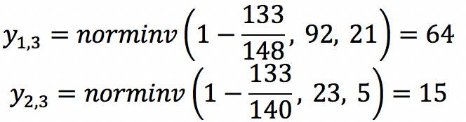

By adding the values together, we can get the total protection level in period 3 is 79.

- **Method b**

Here, we will aggregate class 1 and 2 into a new class {1,2}. The distribution of class {1,2} can be calculated by

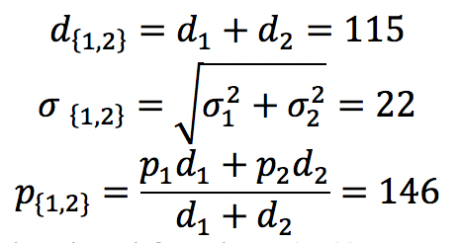

Then, we can calculate the protection level for class {1,2}:

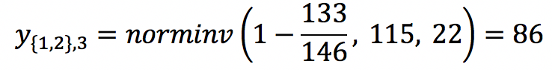

**Protection level calculation for period 2**

In period 2, we only need to protect rooms for class 1. The protection level can be calculated using Littlewood’s formula

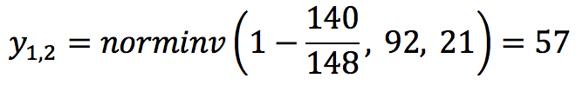

**6. Solution to Question 3 - group booking**

After discussing bookings of leisure customers, let’s move on to Group bookings. After plotting the number of group bookings versus days in advance, which is shown in figure XXX, we can find that there is no obvious downward trend in group bookings behavior. This makes sense because group customers tend to book hotel rooms much earlier than leisure customers. If we only look at days that are close to the service day, the booking level will not increase significantly. Based on this observation, we decide a new booking strategy for group customers. For any given day, we will only accept group bookings at period 3, which is 28 days before. Group customers will also receive a more attractive discount – 15% off, which is $126. Using the historic data, we can calculate that the mean and standard deviation of group bookings are 74 and 62 respectively. Then, by using the same elasticity and demand curve, we can get that the mean of group demand will increase to 91 when price is set to be $126.

If we consider both leisure bookings and group bookings, we need to make a trade off. On the one hand, group bookings have high variance, which means that it may have high probability to bring us high revenue. However, on the other hand, the price of leisure booking is higher and we cannot give up this segment. Therefore, we can use the idea of protection level here and calculate the protection level for leisure customers against group customers.

Here we use the same method as aggregating all leisure groups into one new demand group {1,2,3}. The distribution of class {1,2,3} can be calculated by

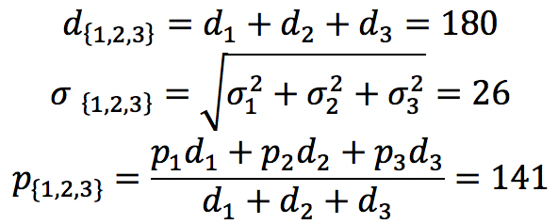

Then we can calculate the protection level for leisure customers against group customers

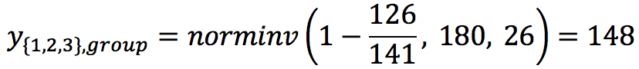

**7. Solution to Question 4 - Overbooking**

Assuming that the reservations of group travelers are not refundable, we just consider the overbooking limit for leisure travelers. With the no-show data, we count the frequency of each “no-show” number and calculate the probability of each “no-show” number based on the frequencies. Based on historical data, the mean of no-show is 2.38. So we assume that the no-show data is in poisson distribution with λ=2.38. The actual probability and fit probability is shown below.

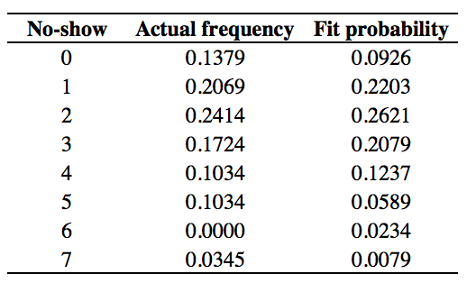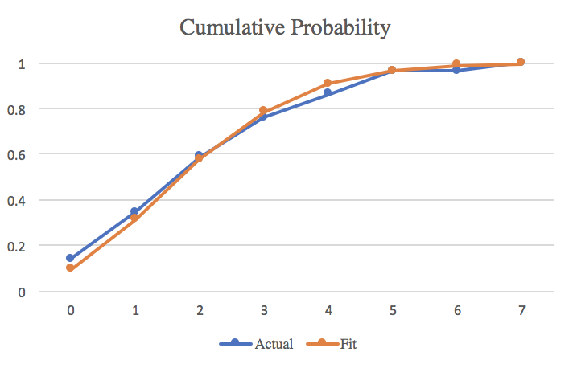

Recall the formula of finding optimal overbooking:

Increase b while p/d>G(b-C) and stop when G(b-C)<=p/d.

From the calculation above, the aggregate price for leisure customer is $141 while the accommodation fee(from the case) is $300, and then we can get:

p/d=0.47.

According to the value of p/d and the fit cumulative probabilities, the optimal overbooking limit should be 1 room and the total reservations of Rose Hotel should be 301 rooms.

**8. Conclusion**

Based on our calculations and analysis, we develop new differential pricing strategy, protection levels, and overbooking level for Rose Hotel to improve its revenue. For leisure travelers, rooms can be reserved at $133 for 28 days in advance, at $140 for 14 days to 28 days in advance, and at $148 for less than 14 days in advance. Group travelers can only make reservations at $126 per room for 28 days in advance. Considering both leisure travelers and group travelers, the protection level for leisure travelers in Period 3 (28 days in advance) should be 149 rooms. Considering only leisure travelers, the protection level for full-price rooms and 5%-discount rooms in Period 3 is 86 rooms and the protection level for full-price rooms in Period 2 (14-28 days in advance) should be 57 rooms. When the reservations of group travelers are not refundable, the total reservations with overbooking of Rose Hotel should be 301 rooms.

Although we have basically solved the questions we proposed, it is admittedly that since we made some strict assumptions, e.g., the full price is identical across each room, which violates common sense that prices are different in terms of different rooms (e.g. double king room, suite, etc.). Therefore, we can still work on the case future to take it into consideration in the future.